Supplemental tables

Table S1. Sampling times. Sampling was at BBCH 10, 12 and 21. Note that accessions Metalla, TRI 1774 and Substance were sampled on later time points due to later development.
Accession | Name | BBCH 10 | BBCH 12 | BBCH 21
Bulk soil | Bulk soil | Oct 31 | Nov 9 | Nov 29
Nordgen NGB22783 | Metalla (selection) | Nov 8 | Nov 16 | Dec 6
Nordgen NGB22756 | Einkorn wheat, Søtofte | Oct 31 | Nov 10 | Nov 29
Nordgen NGB10931 | TRI 1774 | Nov 6 | Nov 16 | Dec 6
Nordgen NGB4802 | KVL 2379 | Oct 31 | Nov 10 | Nov 29
Nordgen NGB8190 | Emmer | Oct 31 | Nov 10 | Nov 29
Nordgen NGB8967 | Hallets | Oct 31 | Nov 10 | Nov 29
Nordgen NGB4770 | ALS | Oct 31 | Nov 10 | Nov 29
Nordgen NGB7032 | Kolbe | Oct 31 | Nov 10 | Nov 29
Nordgen NGB8979 | Lys Østpreussisk Hvede | Oct 31 | Nov 10 | Nov 29
Nordgen NGB5147 | SquareHead II | Oct 31 | Nov 10 | Nov 29
Nordgen NGB22516 | Oberkulmer (selection) | Oct 31 | Nov 10 | Nov 29
N/A Modern cultivar | KWS Desanto | Oct 31 | Nov 10 | Nov 29
N/A Modern cultivar | Substance | Nov 8 | Nov 16 | Dec 6
N/A Modern cultivar | Sheriff | Oct 31 | Nov 10 | Nov 29
N/A Modern cultivar | Torp | Oct 31 | Nov 10 | Nov 29

Table S2. Sampling and sequencing strategy. Number of bacterial and fungal reads are shown for each sample.

Excel sheet – This file was omitted by the authors in this version of the paper.
Table S3. Alpha diversities of bacterial communities.
VarType | Measure | BBCH | Mean_diversity | Std_diversity | TukeyHSD_test
Bulk soil | Observed | 10 | 1119,933333 | 27,342275 | d
Modern cultivars | Observed | 10 | 689,7916667 | 115,838065 | ab
Landraces + Tas | Observed | 10 | 811,9722222 | 145,62366 | a
T. monococcum | Observed | 10 | 600,9047619 | 230,182218 | b
T. turgidum | Observed | 10 | 349,3333333 | 120,001235 | c
Bulk soil | Shannon | 10 | 6,504712213 | 0,04380151 | d
Modern cultivars | Shannon | 10 | 5,142454978 | 0,44380629 | ab
Landraces + Tas | Shannon | 10 | 5,455765599 | 0,69313409 | a
T. monococcum | Shannon | 10 | 4,703394912 | 1,03412438 | b
T. turgidum | Shannon | 10 | 3,313604 | 1,2335467 | c
Bulk soil | Observed | 12 | 1103,444444 | 94,1874608 | b
Modern cultivars | Observed | 12 | 644,0714286 | 159,467339 | a
Landraces + Tas | Observed | 12 | 752,6349206 | 154,630093 | a
T. monococcum | Observed | 12 | 651,2888889 | 143,061085 | a
T. turgidum | Observed | 12 | 572,3333333 | 101,087055 | a
Bulk soil | Shannon | 12 | 6,487801429 | 0,08734745 | b
Modern cultivars | Shannon | 12 | 4,988444344 | 1,06555229 | a
Landraces + Tas | Shannon | 12 | 5,311341976 | 0,8030646 | a
T. monococcum | Shannon | 12 | 5,06322022 | 0,60699283 | a
T. turgidum | Shannon | 12 | 4,544664359 | 0,79611979 | a
Bulk soil | Observed | 21 | 871,6666667 | NA | NA
Modern cultivars | Observed | 21 | 772,9333333 | 44,8866336 | a
Landraces + Tas | Observed | 21 | 808,1805556 | 104,918279 | a
T. monococcum | Observed | 21 | 730,1282051 | 81,5827844 | a
T. turgidum | Observed | 21 | 840,7777778 | 56,0845922 | a
Bulk soil | Shannon | 21 | 6,247222922 | NA | NA
Modern cultivars | Shannon | 21 | 5,816558247 | 0,17646106 | a
Landraces + Tas | Shannon | 21 | 5,566881673 | 0,60130164 | a
T. monococcum | Shannon | 21 | 5,449944216 | 0,40541106 | a
T. turgidum | Shannon | 21 | 5,730885327 | 0,17746994 | a

Table S4. Alpha diversities of fungal communities.
VarType | Measure | BBCH | Mean_diversity | Std_diversity | TukeyHSD_test
Bulk soil | Observed | 10 | 166,794 | 7,873769675 | b
Modern cultivars | Observed | 10 | 100,174375 | 20,66593105 | a
Landraces + Tas | Observed | 10 | 120,7279167 | 28,25027972 | a
T. monococcum | Observed | 10 | 105,7533333 | 36,11638759 | a
T. turgidum | Observed | 10 | 87,8775 | 11,55531443 | a
Bulk soil | Shannon | 10 | 3,752089828 | 0,122786709 | b
Modern cultivars | Shannon | 10 | 2,40904024 | 0,705018171 | a
Landraces + Tas | Shannon | 10 | 2,98039568 | 0,934652297 | ab
T. monococcum | Shannon | 10 | 2,874005081 | 1,082098085 | ab
T. turgidum | Shannon | 10 | 2,364405468 | 0,76073635 | ab
Bulk soil | Observed | 12 | 162,63875 | 5,452824792 | b
Modern cultivars | Observed | 12 | 94,159375 | 28,50202413 | a
Landraces + Tas | Observed | 12 | 122,3491667 | 30,70339422 | b
T. monococcum | Observed | 12 | 106,0025 | 27,87948505 | ab
T. turgidum | Observed | 12 | 64,6025 | 28,1545797 | a
Bulk soil | Shannon | 12 | 3,752583352 | 0,063330853 | c
Modern cultivars | Shannon | 12 | 2,105678698 | 0,983054264 | ab
Landraces + Tas | Shannon | 12 | 2,875567702 | 1,058666093 | ac
T. monococcum | Shannon | 12 | 2,317840751 | 1,014975683 | ab
T. turgidum | Shannon | 12 | 0,834222403 | 0,711303621 | ab
Bulk soil | Observed | 21 | 127,203 | 32,2134727 | a
Modern cultivars | Observed | 21 | 99,848125 | 34,17483094 | a
Landraces + Tas | Observed | 21 | 121,1241667 | 37,00870895 | a
T. monococcum | Observed | 21 | 115,0873333 | 35,26431492 | a
T. turgidum | Observed | 21 | 108,9733333 | 13,51934293 | a
Bulk soil | Shannon | 21 | 2,665933078 | 1,220187906 | a
Modern cultivars | Shannon | 21 | 2,214768568 | 1,041533578 | a
Landraces + Tas | Shannon | 21 | 2,611834124 | 1,219252859 | a
T. monococcum | Shannon | 21 | 2,379160559 | 1,192045984 | a
T. turgidum | Shannon | 21 | 1,925138841 | 0,371161752 | a

Supplementary figures
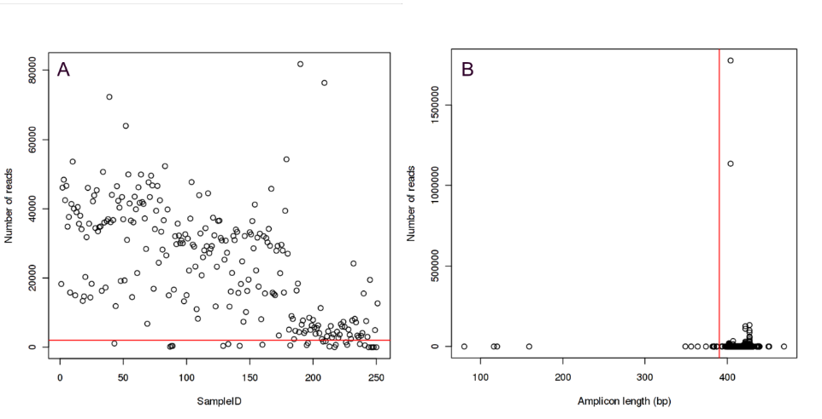
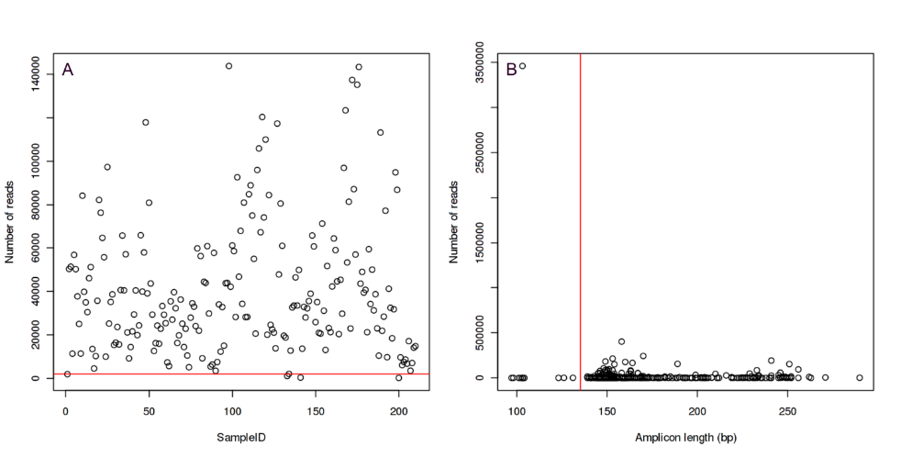
Figure S1. Overview of the bacterial 16S amplicon (top panels) and fungal ITS amplicon (bottom panels) sequencing quality: (A) number of reads per sample and (B) the length of unique amplicon sequences. Red lines represent cut-off values for removing low quality samples and sequences.

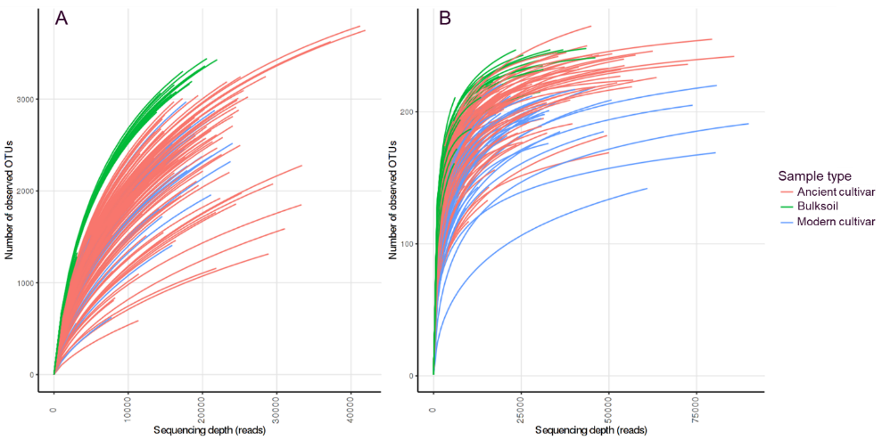
Figure S2. Rarefaction curves for (A) bacterial 16S rRNA amplicon library and (B) fungal ITS amplicon library.

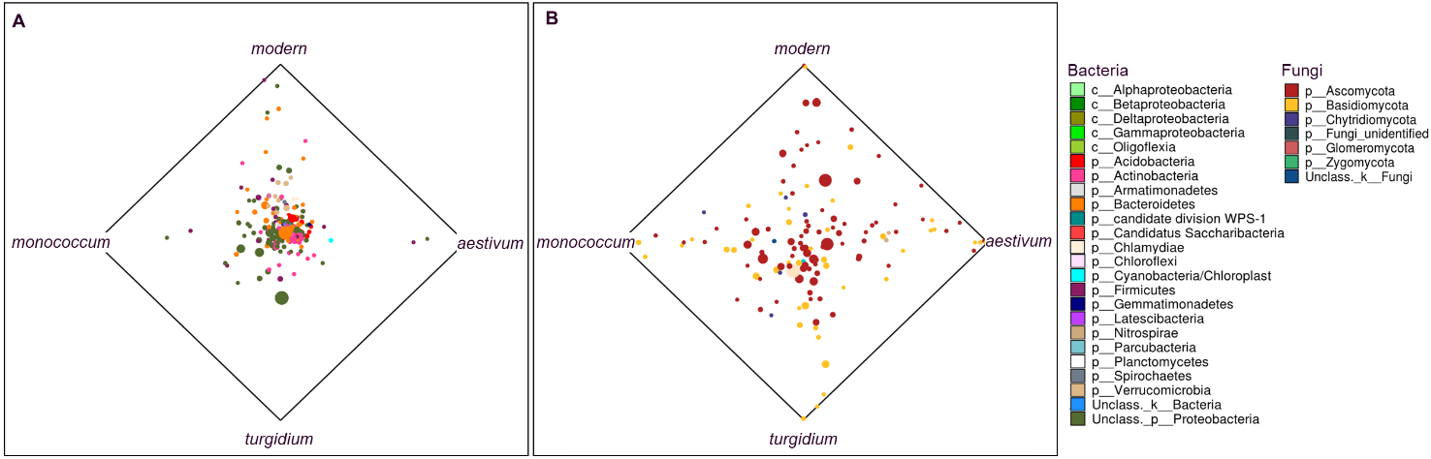
Figure S3. Comparison of the frequency of observation of unique genera of bacteria (A) and fungi (B) in the roots of modern and old (‘monococcum’ = Tm, ‘turgidium’ = Tt and ‘aestivum’ = landraces) wheat varieties.

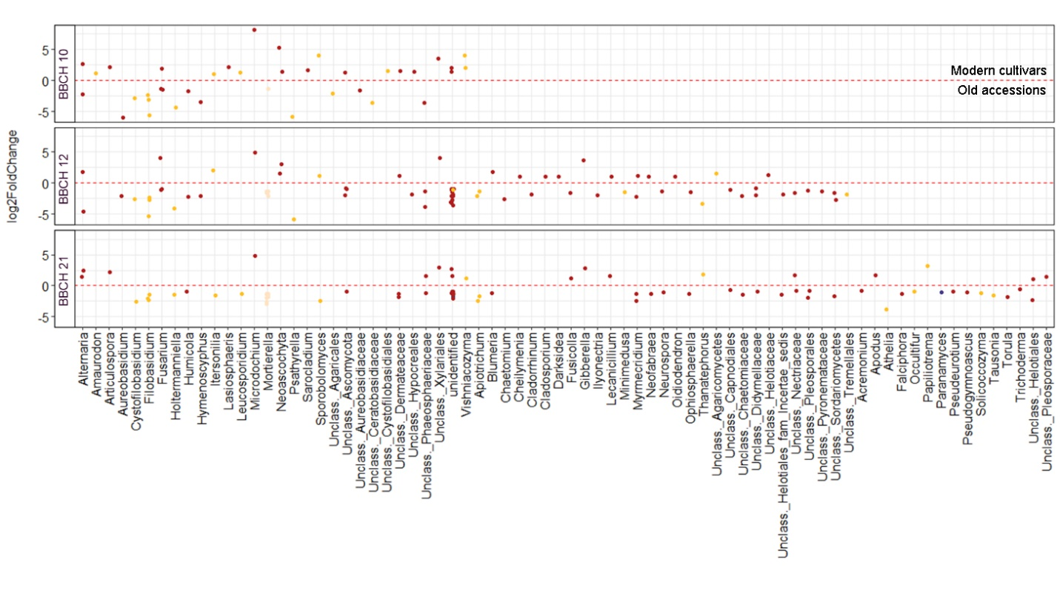
Figure S4. Fungal genera significantly enriched in the roots of old accessions (log2Fold change <0) when compared to the modern cultivars (log2Fold change >0). “Old accessions” depicted in this figure groups the wheat ancestors Tm and Tt, landraces and Tas. “Modern cultivars” groups the commercial cultivars KWS Desanto, Substance, Sheriff and Torp.

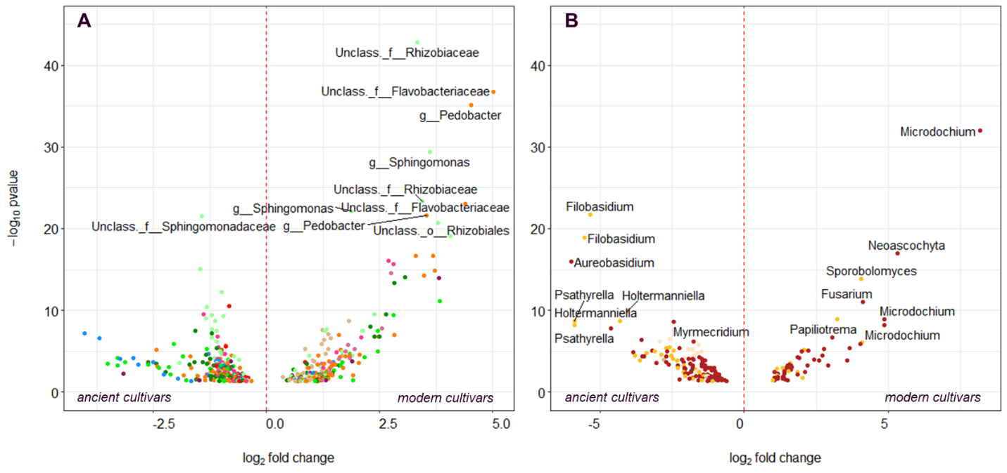

Figure S5. Comparison of unique bacterial (A) and fungal (B) OTUs enriched differentially in ancient and modern cultivars. “Ancient accessions” depicted in this figure groups the wheat ancestors Tm and Tt, the chosen landraces and Tas. “Modern cultivars” groups the commercial cultivars KWS Desanto, Substance, Sheriff and Torp.

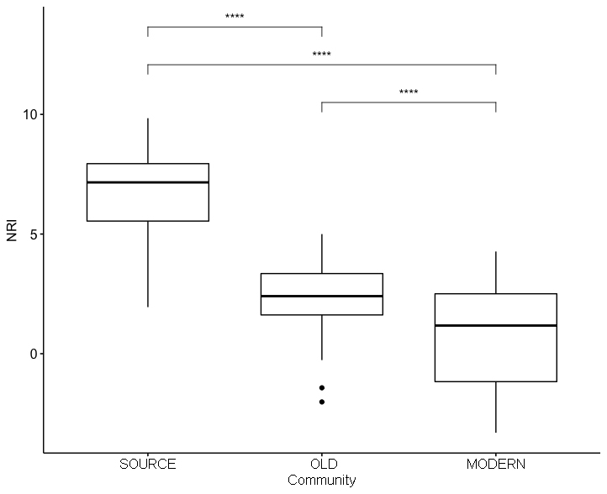
Figure S6. Average values of Net relatedness index (NRI) for samples from bulk soil (SOURCE) and roots of old wheat accessions (OLD) and modern wheat cultivars (MODERN). Wilcoxon Test was used for statistical test.

